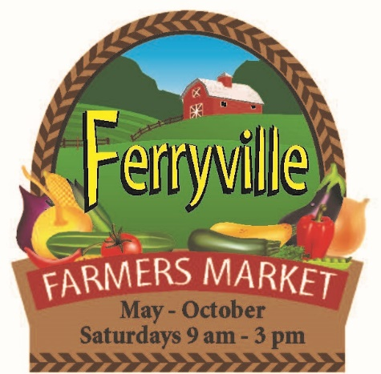
Ferryville Farmers Market
FALL FEST 2023 REGISTRATION FORM
September 16, 2023
PRINT:
Name____________________________________
Street Address_____________________________
City__________________ State_____ Zip______
Phone: ( )-____ - ____ Cell: ( )-____ - _____
Email:____________________________________
Products to be sold:_________________________
SEPT. 16TH Fee: $20.00 Season Pass Vendor or $25 Weekly Vendor. Electrical Fee $3 (if used)

Checks payable to Ferryville Farmers Market. $35 charge for NSF checks
Attn: Janelle Anderson, 58714 Buck Creek Road, Ferryville, WI 54628
Cell: (715) 216-1411 Email – janelleanderson79@yahoo.com

Or Sherry Quamme, 14767 Eagle Ridge Road, Ferryville, WI 54628
Cell: (920)-210-4560 Email: squamme43@gmail.com

